**How to access files with OneDrive.**

1: You will access OneDrive through file explorer. File explorer is the folder on your taskbar.



2: When you select file explorer, a new screen will open. You will see OneDrive- City of Anderson, SC.

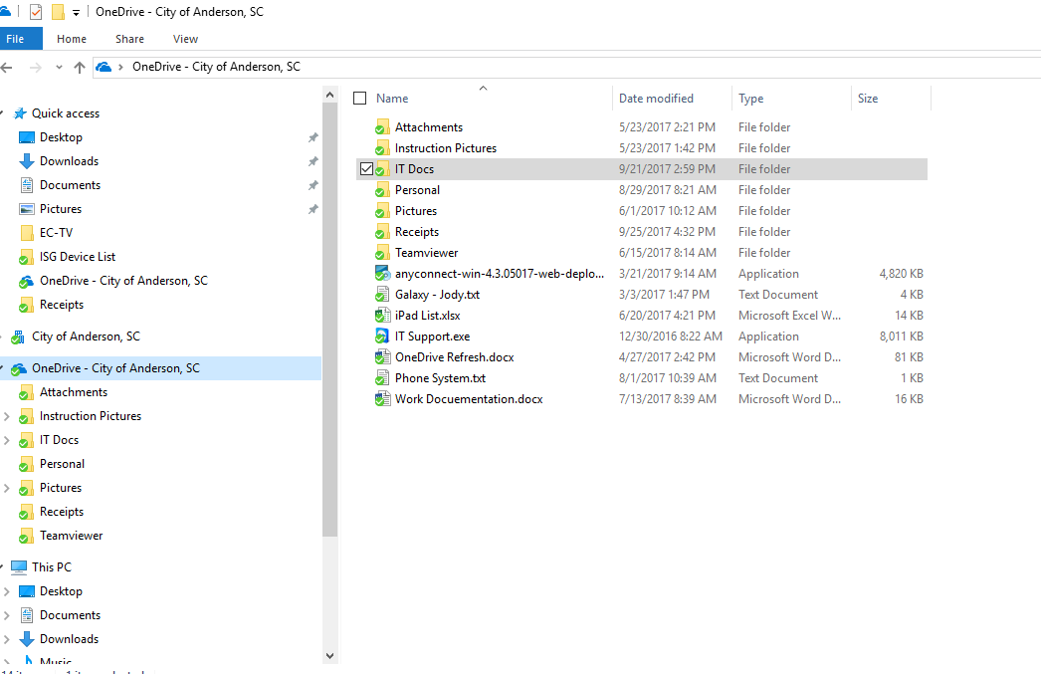

3: When you need to access you files, select OneDrive and double click the file to open.

**How to save files to OneDrive.**

1: With a document open, such as Word, Excel or Adobe, select File and Save AS. 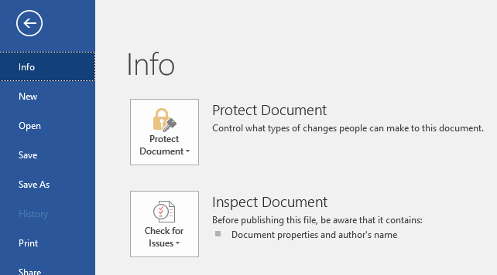

2: Select Browse.

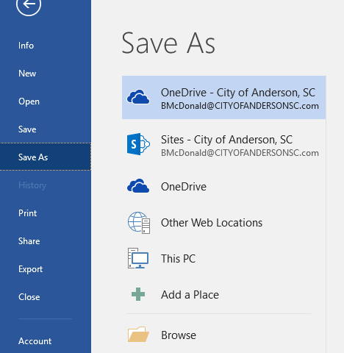

3: Select OneDrive- City of Anderson, SC from the list. Name the file accordingly. Click Save.

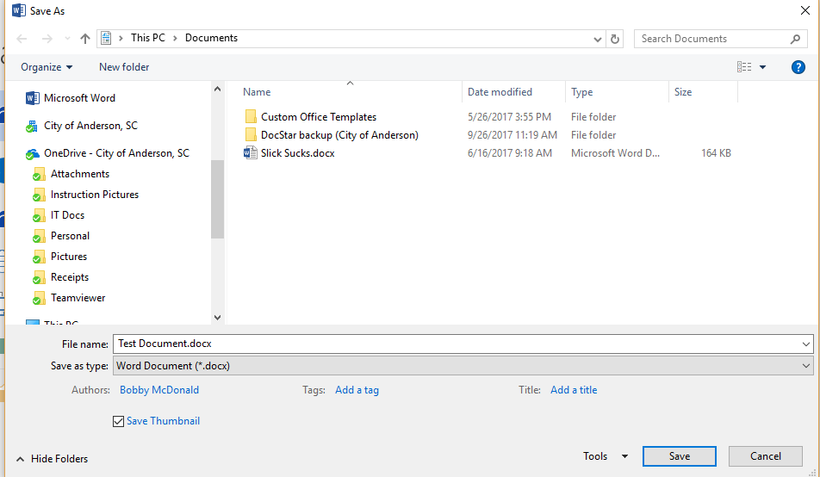

4: To make sure your file is being synced with the cloud, go back to file explorer and verify there is a green check mark on your files. A blue arrow means the file is in the process of being synced. A red X means the file is not being synced and there is an issue with the file.

