Instructions to access City Email account.

1. Navigate to [portal.office.com](http://www.portal.office.com) through a web browser.
2. You will be prompted to Sign in. Enter your City email address.

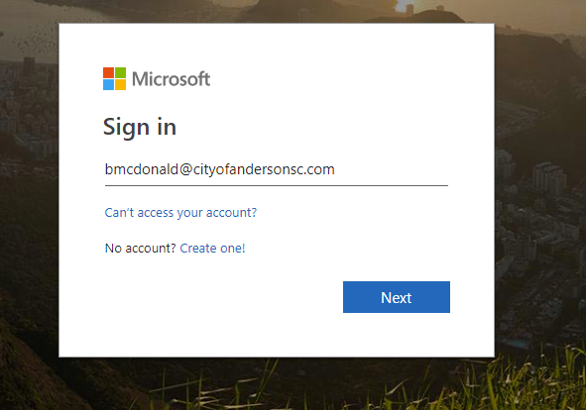

1. Select next and then select Work or School Account. Enter your password you set with the IT department.

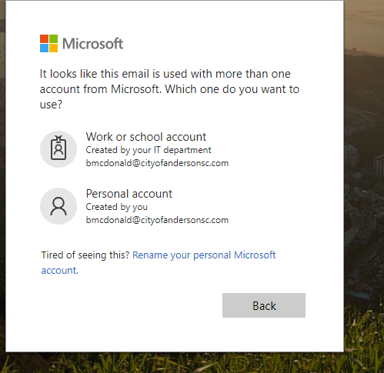

1. You will be prompted to stay signed in. If you want the web browser to remember your credentials select YES. If you do not then select NO.

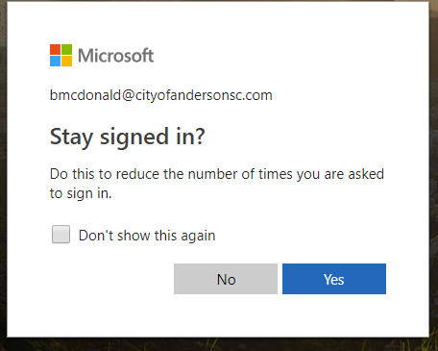

1. Select Outlook from the Apps Menu.

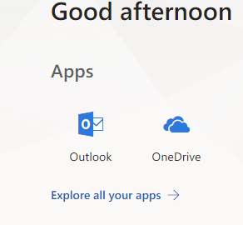

1. Outlook online works very similar to Outlook on your computer.